The Current State of
Religious Pluralism
in Israel

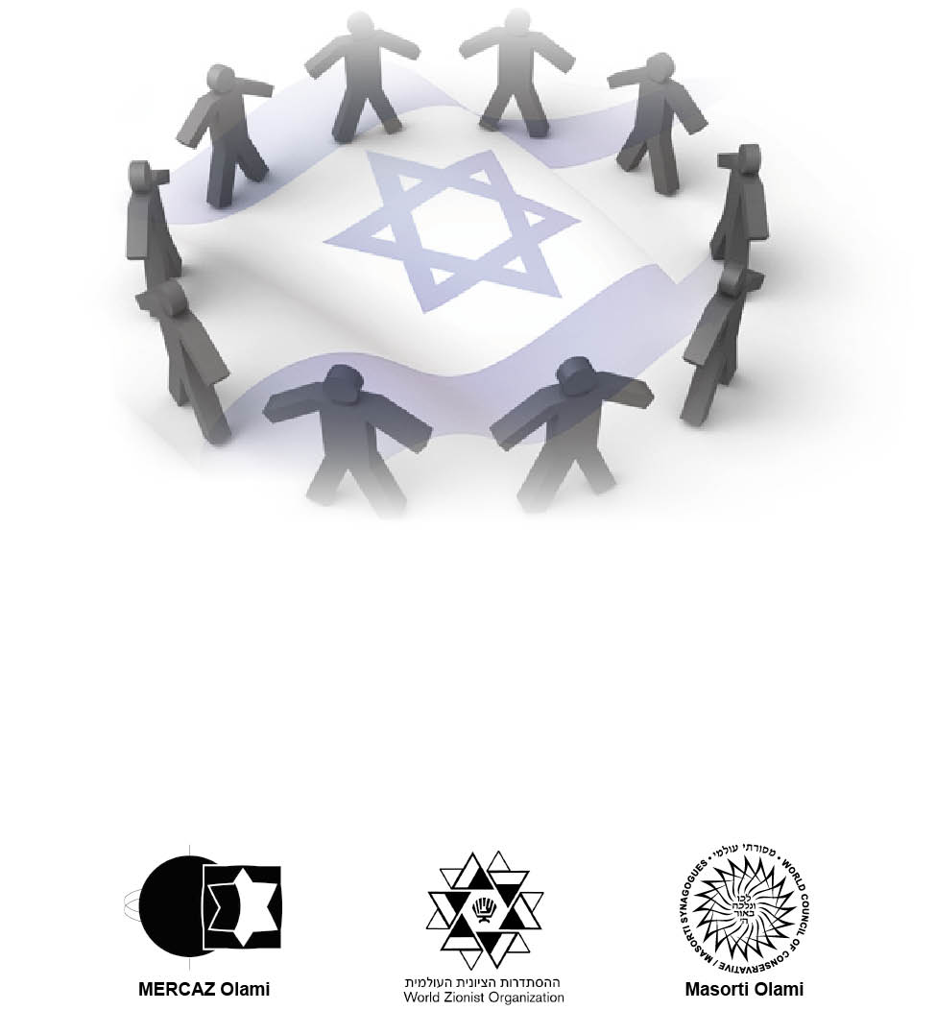
Masorti Europe Leadership Seminar
January 23 – 26, 2014
Valencia, Spain

What do Israelis Think?
From the “The Religion and State Index,” conducted by the Rafi Smith Polling Institute among 800 adult Jewish respondents, published September 2013.

- 83 % of Jewish respondents to a survey said they support “freedom of religion,”
- 61% advocated for the complete separation of religion and state.
- 62% support recognition of civil, Reform and Conservative marriages in Israel, and
- 67% of secular Israeli Jews would like a non-Orthodox alternative to exist for their own marriage or for their children.
- 61% said they would prefer they or their children would be married in a religious Orthodox ceremony in any case.
- 67% preferring the state to allow the opening of shopping centers on Shabbat and holidays outside of cities.
- 41% said they support small-scale operation of public transportation during weekends, and
- 23% said they wished public transportation to be readily available for citizens just as it is on regular weekdays.
- Just over 50%, said they believed the biggest threat to Israelis society was domestic conflict between ultra-Orthodox and secular Jews.
- 82% of the Jewish public said they support compulsory army or national service for ultra-Orthodox yeshiva students, and
- 75% support cuts in state funding to ultra-Orthodox yeshivas to motivate seeking work.
- 63% hold that the government should stop funding ultra-Orthodox schools that refuse to teach core curriculum, which includes math, science, English and civics.
- 67% said they support granting equal recognition by the government to rabbis from all Jewish denominations

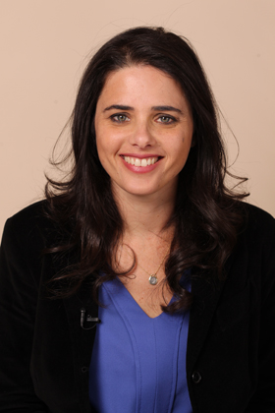
MK Ayelet Shaked (HaBayit HaYehudi) on the Conservative and Reform Movements
"The secular state of Israel does not need this nonsense. There is tradition and Halacha and I as a secular woman should not pray alongside men in the synagogue and all the other nonsense being invented. There is no chance we or someone else will allow Reform Jews to penetrate the Chief Rabbinate or the religious services they provide. They exist abroad, and as Minister of the Diaspora, Bennett has a responsibility to them as well. Discourse with them abroad must be respectful, as long as they haven’t assimilated , they are our brothers and we want them as individuals " – excerpted from a speech by MK Ayelet Shaked (pictured left)

“Much More Work to Be Done” BY AMANDA BORSCHEL-DAN January 2, 2014

(excerpt) The salaries of Rabbi Miri Gold, the rabbi of Kibbutz Gezer’s Kehilat Birkat Shalom, and fellow Reform rabbis in regional communities (as opposed to cities or towns) Stacy Blank of Tzur Hadassah, Benjie Gruver of Yahel and Gadi Raviv of Har Halutz, for the past 18 months were paid this week by the State of Israel in a transfer to the Reform Movement of Israel of NIS 300,000.
Additionally, one Conservative rabbi, Yoav Ende from Kibbutz Hanaton, and one secular rabbi, Chen Bar-Or Tsafoni from Nahalal, met the criteria of the 2012 ruling and also received payment this week from the Israeli government.
“Am I satisfied? At this point yes. We never made it our goal to change the rabbinate, though we have a longer-term goal of separation of church and state. But as long as that doesn’t happen, the government should participate [in paying non-Orthodox rabbis]. “It’s important that this step was taken,” Gold says. “In this case, as far as I’ve seen in the media, it’s very obvious the funds are going to non-Orthodox rabbis and it’s very important that Israel is recognizing us.”
“The transfer of funds from Israel’s Ministry of Culture and Sport to pay the salary of Rabbi Miri Gold and other Reform rabbis serving on regional councils marks a historic step forward for the Reform and Masorti movements in Israel. The Rabbinical Assembly applauds this important victory for religious equality that holds great promise for the unity of the Jewish people around the world,” writes Rabbi Julie Schonfeld, executive VP of the Rabbinical Assembly, the international association of Conservative and Masorti rabbis.
The Conservative movement also has a stake in the ongoing battle for recognition and parity for city and town neighborhood rabbis. This fight is scheduled to have its day in the Israeli Supreme Court later this month and centers around two Reform and two Conservative rabbis in Jerusalem.
“It’s not that the political arena has changed, it’s that the Israeli society has changed. Today in Israel, the political arena is only a reflection of what happens in the field,” says Yizhar Hess, the executive director of the Masorti movement in Israel.
“If half a million Israelis identify with the liberal movement, today, that means this number jumped by 100% in ten years,” Hess says. The victory is not only in having received the funding, but the reason why the funding is available to Reform and Conservative rabbis. “The Israeli society demanded it,” he says.
“The worldwide support for these issues is critical, not just for Reform, it is something for Jewry worldwide,” says Gold.
In a late December interview with The Times of Israel, former Israeli ambassador to the United States Michael Oren echoes Gold’s sentiments, saying, “if Israel does not work to make itself the nation-state of all the Jewish people, and be truly pluralistic and open about this, then we risk losing these people.”
Also in the interview, Oren says the one thing the Reform, Conservative and Orthodox rabbis he met with in the US agreed upon was their opposition to the Israeli Rabbinate’s monopoly on life events, including marriages and conversions.
Gold, who spends much of her time trying to increase ties between Israel and North American Jews, says, “We’re moving in the right direction, however slowly. It’s been very heartwarming to see the army of support” for her struggle, but “there’s much more work to be done [for pluralism in Israel].”
“There’s no sitting and resting on our laurels,” says Gold.
Hess agrees and says, “Israel deserves to have more than one way of being Jewish.”

Op-Ed: On the rights of non-Orthodox rabbis, where’s the outrage?
By Julie Schonfeld January 17, 2014 8:00am NEW YORK (JTA) –
The good news is in: Rabbi Avi Weiss’ conversions will be accepted in Israel.
I am glad to see that the religious integrity and leadership of Rabbi Weiss has been acknowledged. Undoubtedly, this course correction on the part of the Israeli Chief Rabbinate is due in part to the hue and cry of influential Jewish leaders, many of whom are not Orthodox, who are to be praised for speaking out.
Of course, my conversions are not recognized in Israel. Nor are those of my 1,700 Conservative colleagues, my 2,000 Reform colleagues and my 300 Reconstructionist colleagues. The fact that Jewish leaders and major organizations are stepping up to address the issue of pluralism is a wonderful step forward and one that we should all applaud and encourage.
But why does this only happen when an Orthodox rabbi’s character is at stake? Where is the statement on behalf of the nearly 4,000 rabbis and the 85 percent of Diaspora Jewry we represent when the derogation of our Judaism is black letter law in Israel?
Weiss himself wrote in October in the Times of Israel that “Israel as a state should give equal opportunities to the Conservative and Reform movements. Their rabbis should be able to conduct weddings and conversions.”
Leaders of Jewish organizations and public figures have criticized Israel in defense of Weiss, something far too few have been willing to do for the Conservative and Reform movements. This double standard was expressed stunningly by U.S. Rep. Eliot Engel.
“If Rabbi Weiss’ credentials are rejected — an Orthodox leader with decades of experience — what does that portend for other strands of American Judaism?“ asked the New York lawmaker, who represents Weiss’ district in the House of Representatives. What indeed?
To those who issued statements in defense of Weiss that were both bold and effective, I thank you. And I call upon you to now issue a statement for Conservative, Reform and Reconstructionist rabbis. Notify your board members and donors that the rabbis who married them, bar mitzvahed their children, buried their parents, and converted their sons and daughters-in-law do not deserve to be called rabbis in the eyes of the Israeli rabbinate. Tell them that none of their life-cycle events count and that the State of Israel does not really think they are Jews for religious purposes.
The American Jewish establishment will not stand for the discrediting of someone known as an Orthodox rabbi. Better than nothing, I suppose, but far less than the Jewish public deserves. Where is the outrage for us? Has the Chief Rabbinate exported its hatred of the streams? Has the Israeli political leadership exported its willingness to ignore the mistreatment of the vast majority of the world’s Jews by an extremist minority?
If we take a long, hard look at ourselves, the best explanation probably comes from a paraphrase of the famous Pogo cartoon, “We have met the enemies and they are (also) us.”
Structural intolerance and discrimination do not only harm the abused but obscure the human dignity of every individual. Such intolerance, allowed to not only survive but thrive, engenders an atmosphere in which it is impossible to treat even your friends and colleagues as your equals. In the words of Maimonides, “A rabbinic prohibition is always and everywhere superseded for the sake of human dignity.”
No one is asking any rabbi or Jew to hold personally by the interpretations of a community or a rabbi with whom they do not agree. But all must be equally respected and acknowledged.
American Jewish leaders derive legitimate authority only on the basis of their integrity and willingness to seek and grasp the convictions of the people they represent. In my experience, the colleagues I serve with are dedicated beyond measure to these ideals. That is what has made this chapter so chilling. We are becoming invisible to ourselves.
As it is written in Ethics of the Fathers, “Other people’s dignity should be as precious to you as your own.”
Rabbi Julie Schonfeld is executive vice president of the Rabbinical Assembly, the international association of Conservative and Masorti rabbis.

MK Elazar Stern: Work in Chabad houses should count as national service Jerusalem Post By SAM SOKOL 01/01/2014 01:41
Former IDF Manpower Directorate chief MK Elazar Stern called on Tuesday for the work of emissaries of the Chabad Hassidic movement abroad to be granted the status of national service The Hatnua lawmaker and major-general in the reserves spoke during a meeting of the Special Committee for the Equal Sharing of the Burden Bill. Stern hopes to make his proposal, which the committee passed by a 5-3 vote, a part of the government’s Equality of the Burden Bill.
Chabad emissaries engage in outreach work intended to bolster the religious practice and Jewish identity of secular Jews, but also engage in charitable work that has engendered public support from government officials and civil society leaders. Stern told The Jerusalem Post that Chabad houses serve as de facto “embassies of Israel” and that they provide services to Jews regardless of whether “they are religious or not.”
“They do much of their work under difficult conditions,” he added, explaining that giving such recognition to members of the hassidic movement would bolster connections between the ultra-Orthodox and the state.
While Chabad is non-Zionist, it is strongly pro-Israel. Members of the movement tend to side with the national- religious camp on settlement issues and IDF service is not stigmatized in the community as it is among the members of other ultra-Orthodox groups.
While Chabad spokesmen declined to comment on the proposal, a source within the movement told the Post that emissaries increasingly are from abroad, although there is still a significant number of Israelis involved in the group’s foreign operations.
The committee voted in favor of sending the bill onto the Knesset on 12/31/13:

For: MK Elazar Stern, MK Meir Porush, MK Tzachi Hanegbi, MK Dudu Rotem and MK Ariel Attias
Against: Committee Chairperson, MK Ayelet Shaked, MK Ofer Shelach, MK Omer Bar-Lev

Netanyahu to Reform Jews: Western Wall belongs to all

In speech via satellite at URJ biennial, Netanyahu stresses Israel is homeland for all Jews; says Iran must be stopped
BY TIMES OF ISRAEL STAFF AND JTA December 16, 2013, 12:34 am
“I’m committed to making sure all Jews feel at home at our holiest site,” he said. “Israel is, and it must continue to be, the homeland of the entire Jewish people, the entire Jewish people. That’s the place where all Jews – including Reform Jews – experience nothing less than ‘audacious hospitality.’”

He said the Wall, while located in Israel, belonged to the entire Jewish people, and that he was determined to ensure that all Jews felt at home there. “The Western Wall is in Israel, but it belongs to all of you. It belongs to you and to me, to all of us. It belongs to all the Jewish people,” he said, promising to ensure that the Wall “is a source of unity, not division, unity, a place where all Jews feel at home.”

Netanyahu thanked Rabbi Rick Jacobs, president of the Reform movement, for his efforts in support of an interdenominational compromise at the Western Wall. He also thanked the Reform movement for its efforts to strengthen Jewish identity and American Jews’ connection to Israel.

Jacobs, in turn, praised Netanyahu for his role in securing an agreement with the Women of the Wall movement, over an alternative section of the wall to be used for non-Orthodox prayer.

“To us, it is a symbol of the day when those from the non-Orthodox streams will stand equal with the Orthodox rabbinate and community in the eyes of the state,” Jacobs stated. “It is a symbol of your efforts and ours to resist the attempts of those who would turn back the equality advances of women in Israel. Before all those assembled here, I want to acknowledge your personal role in achieving at the Kotel something that, when fulfilled, will be a historic transformation.”

