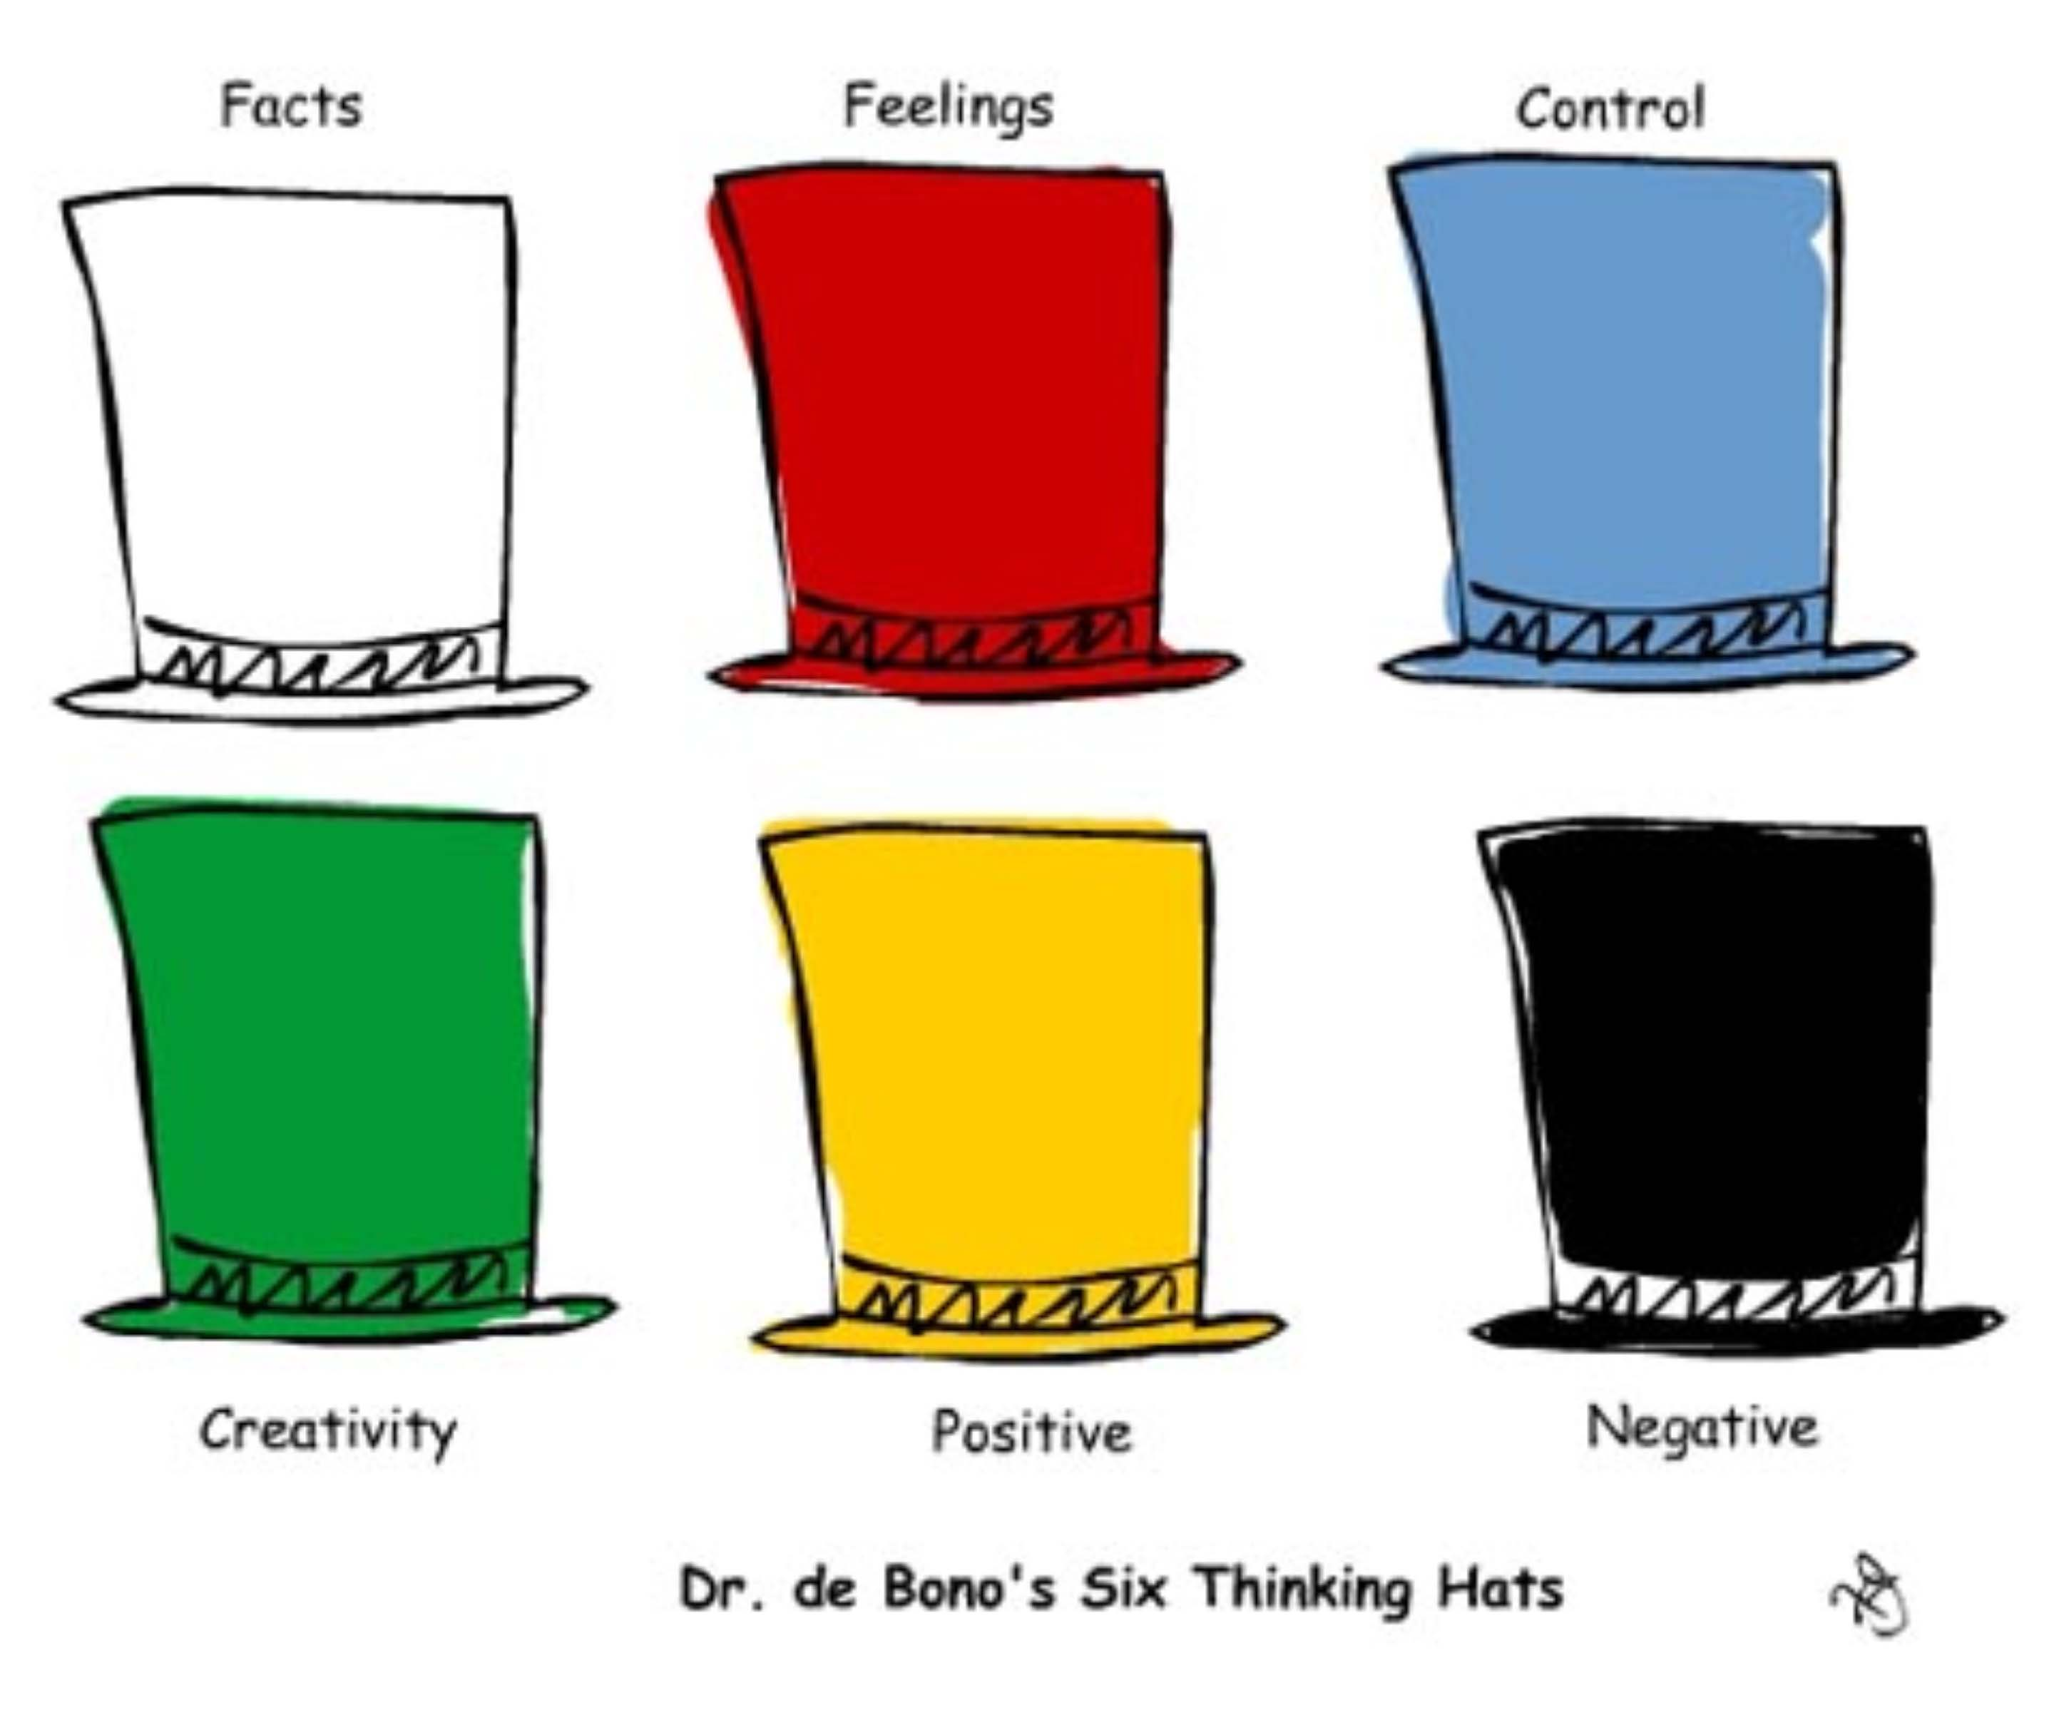

\* What is wrong with this?

\* Will this work?

\* Is it safe?

\* What are the good points?

\* Why can this be done?

\* Why is this a good thing?

\* What thinking is now needed?

\* Where do we stand?

\* What is to be achieved?

\* What information do I have?

\* What information do I need?

\* What are the facts?

\* What new ideas are possible?

\* What are my suggestions?

\* Can I create something new?

\* How do I feel about this?

\* What do I like about it?

\* What don’t I like about it?

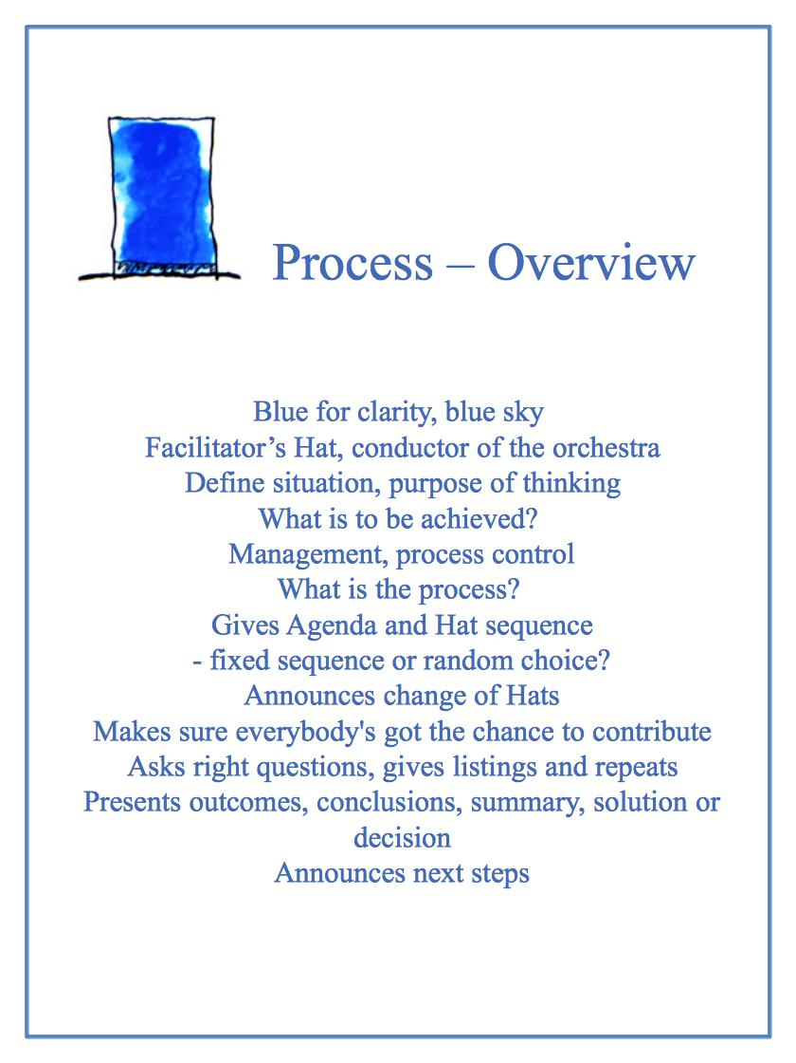

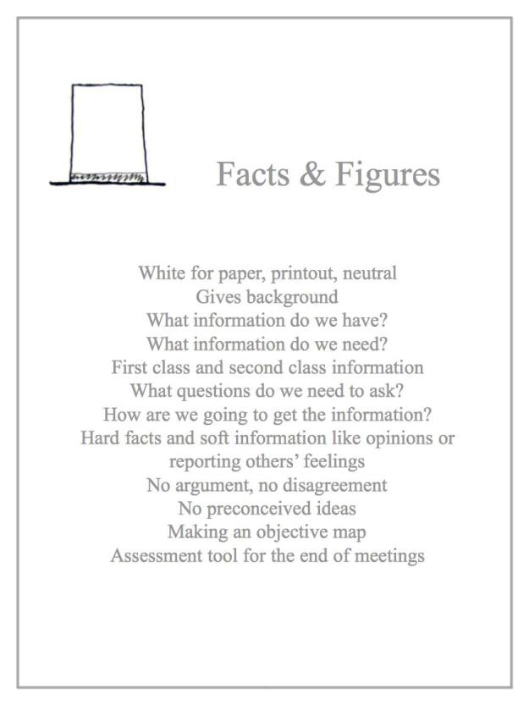

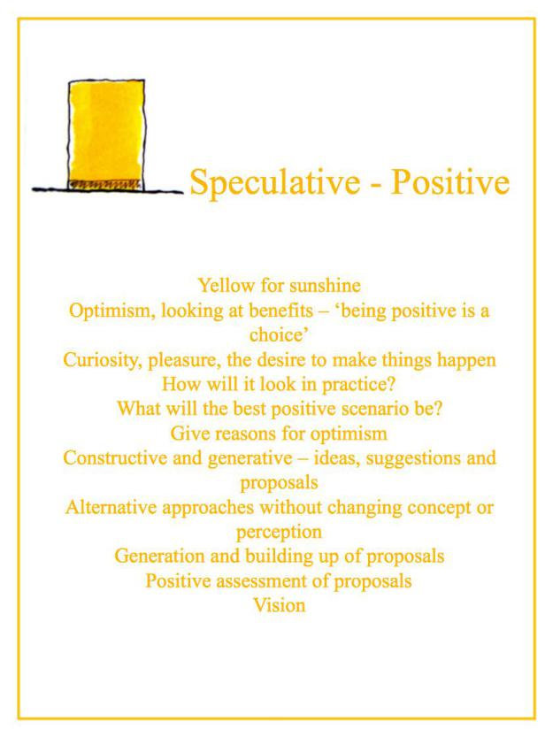

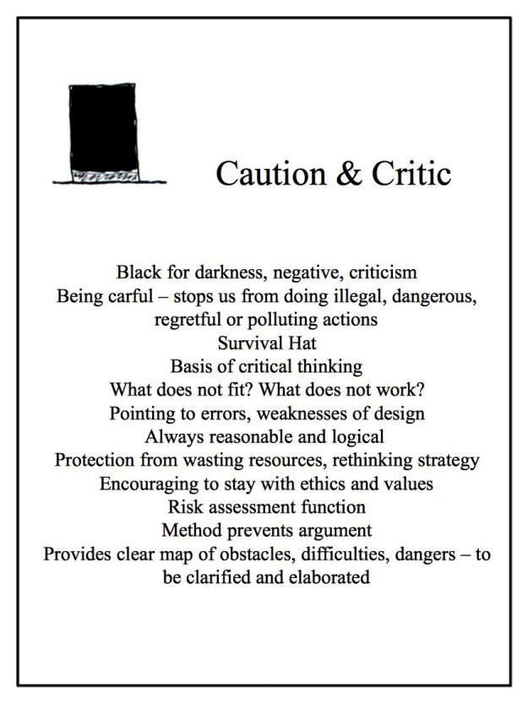

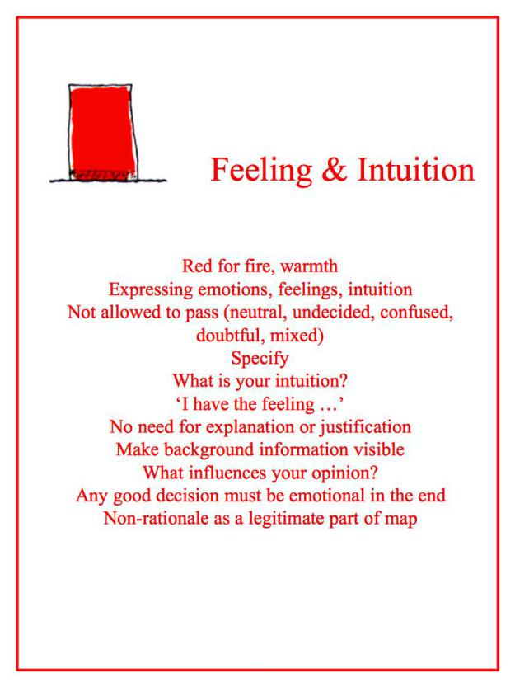

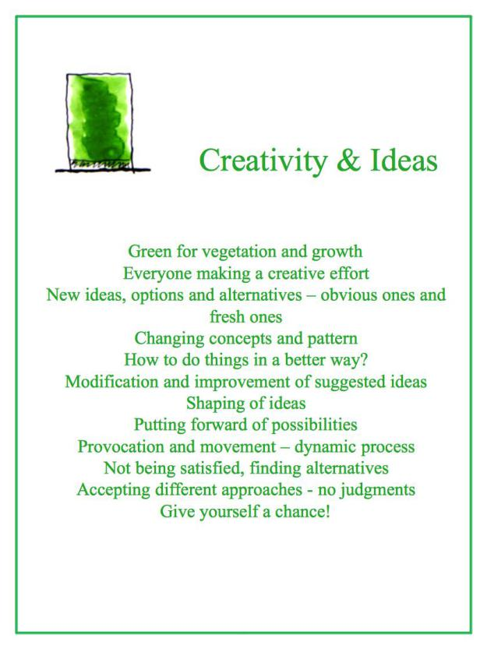

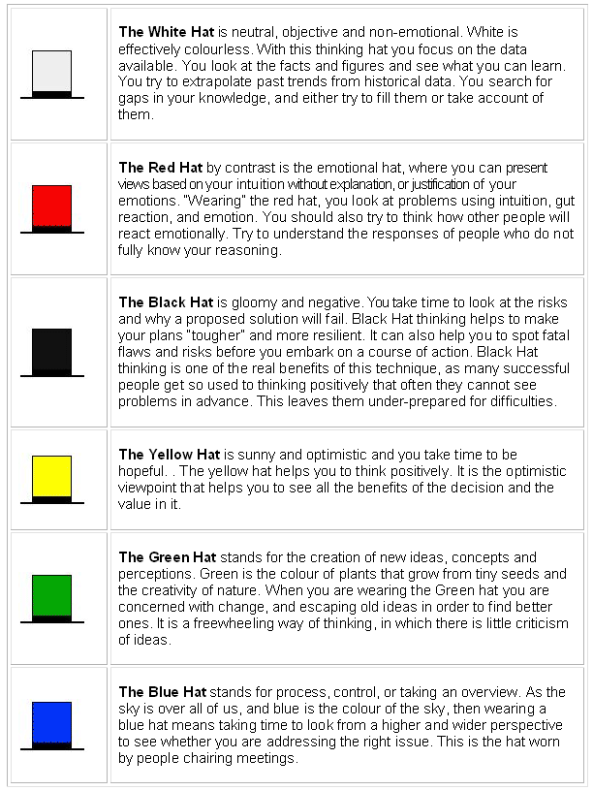

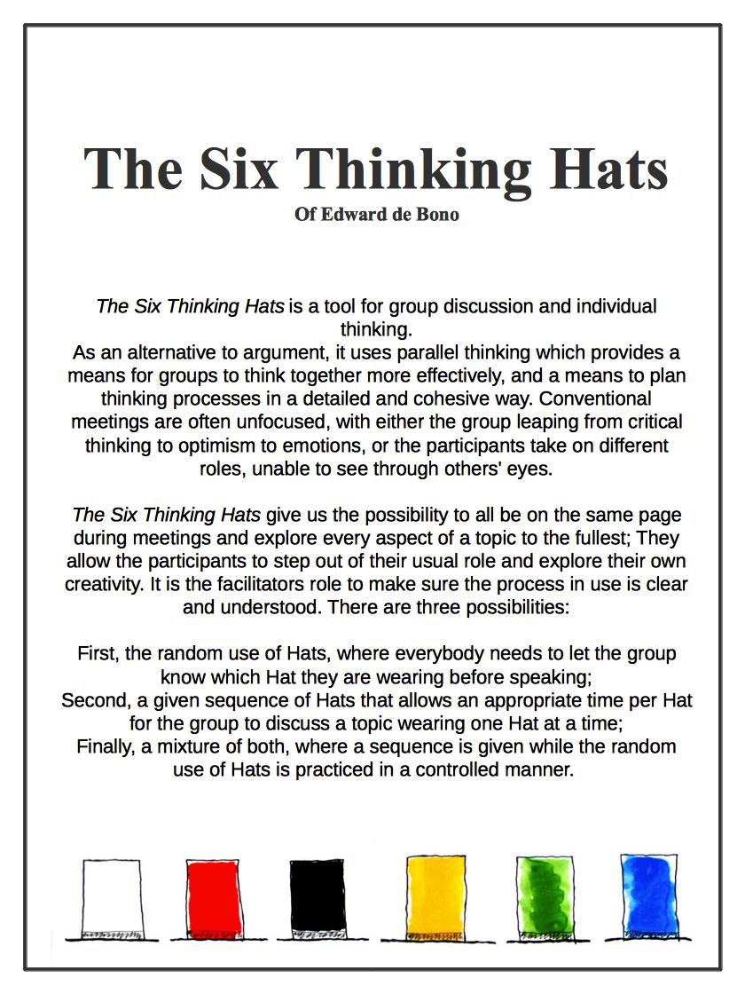

Edward De Bono. *Six Thinking Hats* (1985)