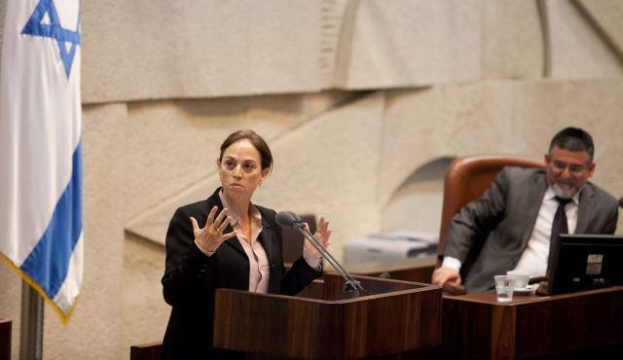
Note: Dr. Ruth Calderon, MK (above), founder of a secular yeshiva in Tel Aviv, spent several years living in New York recently, teaching at the JCC in Manhattan and other venues. This was her inaugural speech in the Knesset this week as a member of Yair Lapid’s Yesh Atid party.
According to Dr. Ruth Calderon, a newly elected member of the Israeli Knesset (parliament), you find that Jew in Israel. She identifies herself as having been “not acquainted with the Mishna, the Talmud, Kabbala or Hasidism” but rather raised in a society that was busy building a nation, protecting its borders and developing a start-up nation.
Her imperative is that “The time has come to reappropriate what is ours, to delight in the cultural riches that wait for us, for our eyes, our imaginations, our creativity.” …The Torah is not the property of one Movement or another. It is a gift that every one of us received, and we have all been granted the opportunity to meditate upon it as we create the realities of our lives.” MK Calderon states further that it must belong to all of Israel: “Torah scholar, man or woman, based on the quality of their study, not their communal affiliation; when secular and pluralistic yeshivot, batei midrash, and organizations win fair and equal support in comparison to Orthodox and Haredi batei midrash. Through scholarly envy and healthy competition, the Torah will be magnified and glorified.” She concludes with a prayer “May it be Your will, Lord our God, God of our fathers and mothers, that I leave this house as I entered it – at peace with myself and with others. May my actions benefit all residents of the State of Israel. May I work to improve the society that sent me to this chamber and cause a just peace to dwell among us and with our neighbors.” And let us say – Amen.

Issachar & Zevulun Philosophy
The unique philosophy of the kollel, in which members are subsisting entirely on support from others, is part of an overall philosophy of Orthodox Judaism, that God meant Jews to primarily occupy themselves in this world with the study of Torah, and gave certain Jews more of a propensity to work with the intention that they should support the 'learners'. In orthodox Judaism this has become known as the 'Issachar-Zebulun' partnership, after the first recorded relationship of this sort in the Bible, where Jacob on his deathbed instructs a more business-inclined brother to support his studious sibling Issachar. The reward of the supporter is seen to be proportionate, for example in an ideal partnership (50/50 division of the money) the business partner is considered to have an equal portion in the learner's World-To-Come earned by his studying. - Wikipedia
Do not say “when I have leisure, I will study” for you may never have leisure. Pirkei Avot 2:5
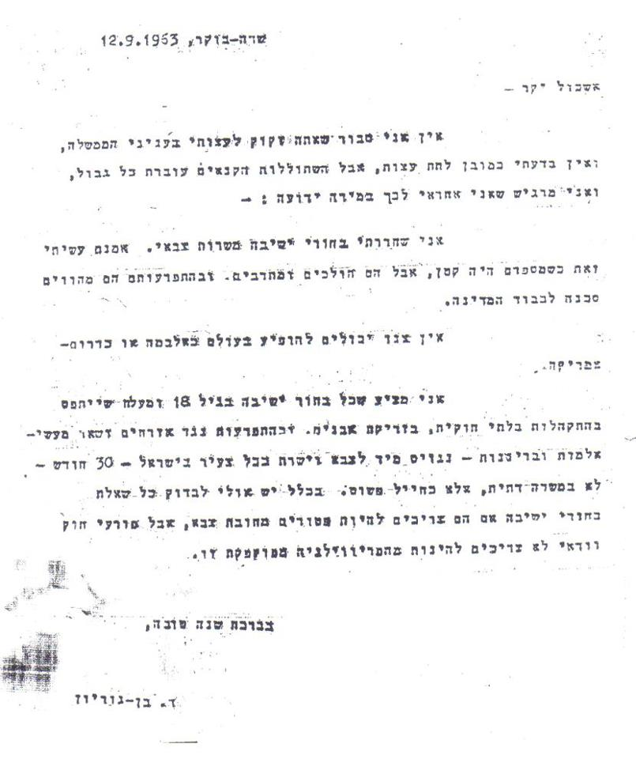
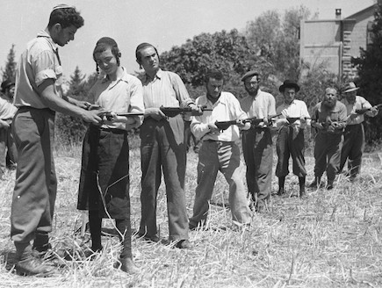
1963 – Letter by David Ben-Gurion
1948 – War of Independence
Israel
Or This?
New York City
This?

Women to get more say in appointing religious judges
By GAVRIEL FISKE June 11, 2013, 2:24 pm
Women will in the future enjoy greater representation on the Selection Committee for Rabbinical Judges, which appoints religious judges for Jewish communities throughout Israel, according to a law passed by the Knesset on Tuesday.

The law, sponsored by MKs Shuli Moalem (Jewish Home) and Aliza Lavie (Yesh Atid), stipulates that four spots on the committee be assigned to women. Three of those are to be representatives from the government, the Knesset and the Israeli Bar Association, which each send two representatives to the selection committee, and the fourth is to be a female expert on religious law appointed by the justice minister.

The law also raises the number of selection committee members from 10 to 11, with the remaining four members to be appointed by the Chief Rabbinate.

However, the current selection committee, which has no female representation, will not be affected by the new law, which will only come into effect during the next selection cycle.
The bill passed after a contentious debate that lasted into the wee hours, and was strongly opposed by the ultra-Orthodox parties.

Israel's Religious Services Ministry to allow non-Orthodox, state-funded community rabbis (excerpt)
By Yair Ettinger | May.30, 2013 | 11:58 PM |
In another move toward recognition of non-Orthodox Jewish movements, the Religious Services Ministry announced Thursday that it plans to abolish the institution of state-appointed neighborhood rabbis. Instead, financial support will be given to communities that request it for rabbis of their own choice, including non-Orthodox ones.

The plan was unveiled in a brief submitted to the High Court of Justice Thursday in response to a petition by the Reform and Conservative movements and several of their community rabbis. The petition had demanded these rabbis receive a salary from the state, just as Orthodox neighborhood rabbis do. It also asked that the city of Jerusalem reserve at least two of its neighborhood rabbi positions for non-Orthodox rabbis.

In its response, the state asked the court to postpone hearing the case to give it time to implement a planned reform of religious services. Under this reform, positions for neighborhood rabbis who are currently state employees will first be reduced from the current 157, and eventually abolished altogether. Instead, money will be given directly to communities to hire rabbis of their own choice.
The ministry is working on drafting criteria for awarding this funding, the brief said, and these criteria will be "independent of which Jewish denomination the relevant community belongs to."

Historic victory in court for Women of the Wall (excerpts)
By JEREMY SHARON
25/04/2013

In a groundbreaking ruling, the Jerusalem District Court upheld an earlier decision of the magistrate’s court that women who wear prayer shawls (“tallitot” in Hebrew) at the Western Wall Plaza are not contravening “local custom” or causing a public disturbance, and therefore should not be arrested.
Women of the Wall chairwoman Anat Hoffman said the ruling “liberated the Western Wall for all the Jewish people.”
“This is a critically important story for reclaiming Judaism, redefining our values and reclaiming the Wall,” she said. “Women of the Wall have really achieved something for Israeli society and the entire Jewish world.”
On April 11, five women who had donned tallitot during the group’s monthly prayer service were arrested and brought to the Jerusalem Magistrate’s Court. Judge Sharon Larry-Bavly ruled at the time that there was no cause for arresting the women, and that the Women of the Wall’s prayer services did not create a public disturbance.
The Regulations for the Protection of Holy Places to the Jews, dating from 1981, forbid performing religious ceremonies that are “not according to local custom” or that “may hurt the feelings of the worshipers” at the site, where local custom is interpreted to mean Orthodox practice.
These regulations and their interpretation, which a Supreme Court ruling upheld in 2003 and a Justice Ministry directive reiterated in 2005, have been the legal basis for the regular arrests of women who perform Jewish customs at the Western Wall that are usually practiced only by men in Orthodox Judaism.
On Thursday, however, Judge Moshe Sobell upheld Larry-Bavly’s earlier ruling that there was no basis for arresting women over wearing tallitot or performing rites not in accordance with Orthodox custom.
Sobell ruled that the definition of “local custom” did not automatically mean Orthodox practice. He based this decision on the written opinions of several Supreme Court justices from previous cases, particularly that of justice Shlomo Levin, who wrote in a 1994 ruling on the issue that the expression ‘local custom’ does not need to be interpreted specifically as according to Jewish law or the current situation.”
Levin wrote that it was the nature of customs to change with the times, and within that context “[permission] should be given to the expression of a pluralistic and tolerant approach to the opinions and customs of others.”
In reference to the charges of causing a public disturbance and disturbing the peace, Sobell ruled that even if the women had behaved in a way that was disruptive, they were in no way suspected of violent or verbal behavior that would either disturb the peace or endanger the public.
A spokesman for the Jerusalem District Police said that police would “adhere to the ruling of the court.”
Western Wall Rabbi Shmuel Rabinowitz, who has strongly advocated for the preservation of Orthodox custom at the site, said he would turn to the Attorney- General’s Office “to examine the consequences of the ruling and its implications, especially in relation to the decision of the Supreme Court.”
Jewish Agency chairman Natan Sharansky, whom the prime minister had tasked with finding a solution to the issue, said in response that the ruling strengthened the need for a sustainable and agreed solution “that will allow every Jew to feel at home at the Western Wall.”
Sharansky’s plan will allow for the construction of an additional section of the Western Wall Plaza at the southern end of the Wall, “equal in size and height to the northern prayer area,” for egalitarian prayer. That area would be accessible as part of a unified Western Wall complex with a single entrance.
Before the ruling, women are arrested for wearing tallitot while praying at the Kotel.
After the ruling, women are protected from protestors during services.
Before the ruling, women are arrested for wearing tallitot at the Kotel.
After the ruling, women are protected while wearing tallitot and praying at the Kotel.

