MODELS and THEORIES of LEADERSHIP L.E.T. Marseille 25-27 january 2013 – Dina Ben Ezra
Model Name | Basic Assumption | Focus &  Central Question | Content | Major Strengths | Limitations/ Major Criticism | Main Scholars
GREAT MAN  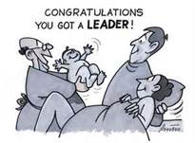 | Leaders are born leaders | Leader centered  Which innate personality traits make a leader? | Intelligence, self-confidence, determination, integrity, sociability, initiative. And also: motivation, cognitive ability, emotional intelligence, cooperativeness, extroversion, openness, conscientiousness, masculinity, etc. These traits have been found over many years of research to be related to leadership or leadership perception. | - Very wide empirical studies support | - Long list of traits  - Culture blind  - Context blind: fails to consider situation, time or followers  - Can’t be taught | Stogdill (1948, 1974)  Kirkpatrick & Locke (1991)  Zaccaro (2007)
Skill Approach  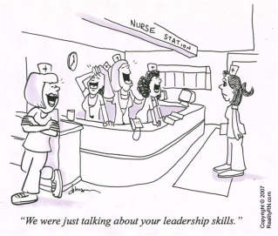  “We were just talking about your leadership skills!” | You can become a leader if you learn the appropriate skills | Leader centered  What do leaders need to know to do? | Descriptive model: it describes leaders according to their skills. Different approaches:  - Technical, human and conceptual skills according to management position (Katz)  - Problem solving, social judgment and knowledge combined with individual attributes, such as cognitive ability, motivation and personality (Mumford et.al.) | - Places learned skills at the center of the leadership process  - Availability | - Does not explain how skills lead to effective leadership performance  - Fails to consider followers  - Mainly based on research in military environment | Katz (1955)  Mumford, et al. (2000)
Behavioral Style Approach  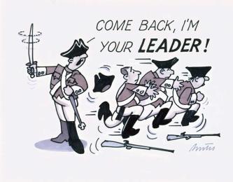 | Leadership  is about how you act | Leader centered  How do leaders behave? | Descriptive model: it identifies two main types of behavior among leaders: 1. Task behavior - structure: assist people to achieve results and 2. Relationship behaviors - create and maintain a positive working climate).  Five main leadership styles:  Authoritarian: high concern for results, low concern for people  Laissez-faire: low concern for results, low concern for people  Country-Club: high concern for people, low concern for results  Team Management/ Coaching: high concern for people, high concern for results  Middle of the road: balancing results and concern for people | - Identifies the main behavior categories of leadership  - Wide empirical support | - Fails to find a style effective in every situation  - Implies that “high high” is better, but limited empirical support for this inference | Blake & Mouton (1964, 1978, 1985)  Blake & McCanse (1991)
Transformational  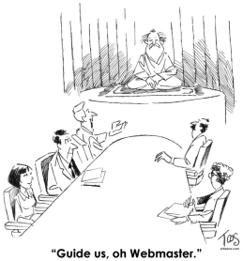 | Charisma and modeling | Leader centered  How do leaders inspire followers?  (A mix of personal traits and behavior) | The importance of: a shared vision, trust, positive self-regard, personal example, challenge the status quo, enhance collaboration, attention to followers needs, and rewards for accomplishments | - Includes growth of followers and their empowerment  - Includes symbolism | - Lack of conceptual clarity  - Suffers from an “heroic leadership bias” | Burns (1978)  Bass (1985)
Contingency Style 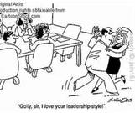  “Oh, I love your leadership style !” | Know your style and check to which situation it fits | Situation centered  Which leadership style is effective in which situation? | Different leadership styles – highly task motivated, socioindependent or relationship motivated – suit different situation variables of leader-member relations (group atmosphere, trust in leader, etc.), task structure (degree of ambiguity), and position power (degree of authority held by the leader). | - Situational  - Predictive of leadership effectiveness  - Empirically tested | - Fails to explain why  - Difficult to implement | Fiedler (1964, 1967)
Situational  Style Approach | Match your style to the development level of subordinates | Task centered  How do leaders best support people in achieving their goals? | Effective leaders have to match their behavioral style (supportive versus directive) to the developmental level of the subordinates (level of competence, motivation, or characteristic) or to the task characteristic (level of ambiguity and complexity) | - Standard for training leaders  - Situational | - Little empirical support  - Controversial finding  - Group dynamics blind | Blanchard (1985)  Blanchard et al. (1993)
Team Group | Leader is a function | Task centered  How the function of leaders improves team effectiveness? | Leadership as a capacity shared among team members. The critical functions of leadership are diagnosis and taking action, choosing between: monitoring versus taking action; meeting task or relational needs, dealing with an internal or external issue. | - Considers group relations and dynamics  - Applicable in changing leadership | - Complex  - Lacks empirical base | Hackman (1990, 2002)  LaFasto & Larson (2001)
Leader Member Exchange  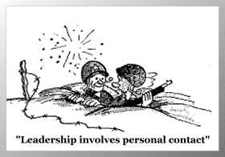 | It is all about high quality mutual relationship | Interaction centered  How do leaders reach a partnership relationship with members? | Descriptive theory: Leadership is seen as a process in which members can shift from a “stranger – out group” phase, to an “acquaintance”, and finally to a “mature partnership – in group”, based on the quality of the relationship, the member level of involvement, and the focus of his/her interest | - Highlights the importance of communication  - Considers group relations | - Theoretical framework not fully developed  - Beware the use of in/out groups | Graen & Cashman (1975)  Graen & Uhl-Bien (1995)
Authentic  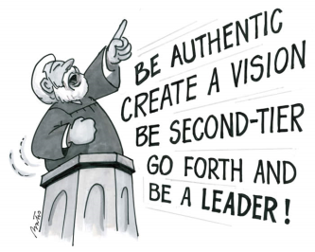 | A good leader is a true leader | Leader and situation centered  Who is a true leader? | As a response to leadership crises, authentic leader demonstrates self-awareness, an internalized moral perspective, the ability to analyze capacity, and transparency. This model also aims to understand the sources of problems and to select appropriate responses. | - Uses positive psychology | - Lacks empirical base  - Does not question authenticity  - Implies “one” good moral  - Not fully developed | Avolio & Gardner (2005)
Main source: Northouse, P.G. (2010). Leadership: Theory and Practice (5th ed.). Thousand Oaks, CA: Sage.

